MANUAL HANDLING IN OFFICES
The Manual Handling Operations Regulations 1992 describes manual handling as the transporting or supporting of a load by hand or bodily force. This means human effort is involved rather than mechanical handling by devices such as powered hoists. However, using a mechanical aid may only reduce (rather than replace) manual handling, as human effort is still required to move the mechanical aid or position the load on the aid. Manual handling includes lifting, putting down, pushing, pulling, carrying or moving a load, which can be an object, person or animal. Human effort may also be applied indirectly, such as by hauling on a rope or pulling a lever. The manual handling regulations were developed to reduce the number of musculoskeletal disorders (MSDs) associated with manual handling. MSDs are said to account for around 40% of all work-related ill health. The Health and Safety Executive reported that 469,000 workers suffered from work-related MSDs in 2017/18 and that 197,000 MSDs were in the upper limbs or neck. General risk assessments of work are required to be completed under the Management of Health and Safety at Work Regulations. Where appropriate, manual handling should be included as a hazard within these assessments. The assessments will need to take into account the individual capability or any pre-existing conditions that would make them more vulnerable in relation to manual handling activities e.g. if women of child-bearing age are employed the general risk assessment completed under the Management of Health and Safety at Work .
PRINCIPLES OF CORRECT MANUAL HANDLING

Work in modern offices involves manual handling although office activities involving this may be taken for granted. For example, moving boxes of stationery or moving desks or office equipment, counts as manual handling. The purpose of these notes is to outline the general principles of correct manual handling and to act as an aide-memoire.
- Plan -The person undertaking the manual handling should assess the load; determine how it will be handled; where it is going; whether a handling aid such as a trolley is needed; or whether another person could assist with the handling.

- Lifting technique - The best handling technique involves suitable balance and avoidance of unnecessary bending, twisting and reaching. Place the feet apart giving a balanced and stable base for lifting with one leg positioned forward of the other and with the 'leading' leg pointing in direction of travel and as far forward as is comfortable (easier if not wearing tight clothing). Bend knees so can easily and comfortably grasp load. Grasp with palms rather than fingers and keep arms close to body allowing whole body to support load.
- Lifting manoeuvre - A person undertaking a lift should lift slowly, smoothly, without jerking and avoiding bending of the lower back. It is important to have the centre of gravity of the load close to the body to prevent excessive stress of the back and to make the strongest muscles of the arm available to hold the load and using the leg muscles to lift the load.

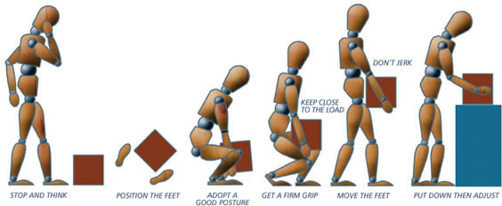

Remember to use the right equipment for the task
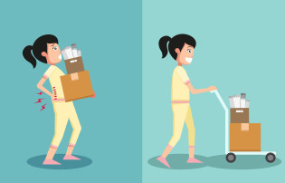
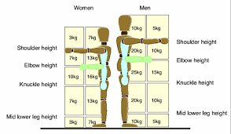
Manual Handling Operations Regulations (MHOR) 1992

2. RISK MATRIX |  | Potential consequence of harm
 |  | 1 – Minor Injury  (e.g. hazard can cause illness, injury or equipment damage but the results would not be expected to be serious) | 2 – Significant Injury  (e.g. hazard can result in serious injury and/or illness, over 3 day absence) | 3 – Major Injury  (e.g. hazard capable of causing death or serious and life threatening injuries)
Likelihood of harm | 1 – Unlikely  (injury rare, though possible) | 1 – Low | 2 – Low | 3 – Medium
 | 2 – Possible  (injury could occur occasionally) | 2 – Low | 4 – Medium | 6 – High
 | 3 – Probable  (injury likely to occur, can be expected) | 3 – Medium | 6 – High | 9 – Extreme

3. RISK EVALUATION
This is calculated by multiplying the likelihood against the consequence e.g. taking a likelihood of 1, which is classified as Unlikely and multiplying this against a Potential Consequence of 2, which is classified as Significant Injury, would give you and overall Risk Rating of 2, which would result in an overall evaluation as a low risk.

1 to 2 = Low risk
Low risks are largely acceptable, monitor periodically to determine situation changes which may affect the risk, or after significant changes

3 to 4 = Medium risk
Medium risks at the upper end of this band should only be tolerated for the short-term and then only whilst further control measures to mitigate the risk are being planned and introduced, within a defined time period. Risks on the lower end should be reduced if practicable.

6 = High risk
High risks activities should cease immediately until further control measures to mitigate the risk are introduced. The continued effectiveness of control measures must be monitored periodically.
9 = Extreme Risk
Work should not be started or continued until the risk has been mitigated. Immediate action is required to reduce exposure. A detailed mitigation plan must be developed, implemented and monitored by senior management to reduce the risk before work is allowed to commence.

What are the hazards? | Who might be harmed? | What are the risks | Are the following control measures in place to eliminate or reduce the risks? | Yes/  No | Corrective actions required | Risk Evaluation |  |  | Risk Rating
 |  |  |  |  |  | Consequence  (1 – 3) | Likelihood  (1 – 3) | Overall risk  (C x L) | Low, Medium or High
Manual Handling | Staff, Visitors  Contractors | Could suffer from back pain and work related upper body disorder due to:  - Using incorrect handling techniques when handling office items (deliveries, boxes, filing etc).  - Poor workstation layout and insufficient working space resulting in poor posture.  - Individuals with health conditions, previous back injuries etc affecting ability to safely handle items  - New and expectant mothers may be more susceptible to injury. | - A risk assessment must be completed for lifting heavy and bulky loads that present a risk of injury e.g. stretching, stooping, and twisting).  - A trolley should be used to transport boxes of paper or other heavy items.  - Using low shelves for storing heavy items and only using high shelves for light items only. | Yes | Nil at present | 1 | 1 | 2 | low
Computer workstation use | Staff | Could develop as a result of  - Inappropriate layout or lack of awareness resulting in poor posture being adopted when using Display Screen Equipment (DSE)  - Working for prolonged periods without change of posture or sufficient break. | - Where desktops, laptops and notebooks are used as a significant part of day-to-day work, a Computer Equipment assessment must be carried out.  - Work should be planned to include regular breaks from the computer.  - HSE leaflet “Are you keying safely” may be issued to DSE users. | Yes | Nil at present | 1 | 1 | 3 | Low
Filling Cabinets |  | - Could topple over if loading is unbalanced.  - Cabinet drawers that have been left open could be a trip hazard | - Filing cabinets should be loaded from the bottom up to maintain stability.  - Where filing cabinets are of the type that allows more than one drawer to be opened at a time, they must be labelled with a warning of a tipping risk.  - Drawers should be closed immediately after use. | Yes | Nil at present | 1 | 1 | 3 | Low

